
Number Talks K-2+
June 11, 2026—Online Course

You will not need to purchase a new copy of “Number Talks in the Primary Classroom” if you already have the book.

Number Talks course $99.00
“Number Talks in the Primary Classroom” (REQUIRED) please order from Didax
By Kathy Richardson and Sue Dolphin
IF YOU DO NOT OWN A COPY OF THE REQUIRED TEXT (above); PLEASE PURCHASE IT THROUGH OUR DISTRIBUTOR, DIDAX. LOCATED IN ROWLEY, MA; IN TIME TO HAVE IT FOR THE COURSE.
YOU CAN PURCHASE THE BOOK AT WWW.DIDAX.COM

PARTICIPANT REGISTRATION FORM

How to register: Please use one registration form for each participant; Registration fee or Purchase order must accompany your registration form. Mail, fax or email your completed form with payment to:
Mail: Math Perspectives, P.O. Box 29418, Bellingham, WA 98228
Email: with Subject line “Online Number Talks Course” to erin@mathperspectives.com

You will be sent a confirmation email or letter when your completed registration is received. Sessions are filled on first-come, first-served basis. Limited space is available.

Participant Information:
Name | District/School | Title/Grade Level
Home Mailing Address | City, State/Province, Zip/Postal code
Work phone | Home phone | Cell phone
School email | Home email
Please check preferred email for Course correspondence.
Would you like to receive our Q&A eNewsletter by Kathy Richardson and other course emails? Yes No
PaYMENT Information:
Check or Money Order: Make payable to Math Perspectives.
Credit Card: Fill out authorization form included or call 360-715-2782.
Purchase Order: Complete all PO information below and provide a copy of the PO with your completed application.
PO Number |  | Total Registrants on PO
Institution | Billing Contact/Title
Billing Address | City/State/Zip
Billing Phone | Billing Fax
Cancellation Policy If you must cancel, a substitute participant is always welcomed. A full refund will be made if written cancellation is received at least 10 days before the first day of the session. If written cancellation is received less than 10 days prior to the session, a processing fee of $50.00 per participant will be charged. Participants who have not provided written cancellation according to this policy and do not attend the course forfeit their entire registration.

CREDIT CARD AUTHORIZATON FORM

Instructions: Please complete all credit card billing information; print legibly using dark ink.
Submit via mail to or call:
Math Perspectives, P.O. Box 29418, Bellingham, WA 98228 Call 360-715-2782

I, ____________________________________________, hereby authorize Math Perspectives to charge my credit card account in the amount of $________________ (including shipping and handling, and/or taxes, if applicable).

Type of card:  VISA  Mastercard
Credit Card number | Expiration date |  | CVC code
Name as it appears on card
Card Billing Address |  | City, State/Province, Zip/Postal code
Contact Phone | Contact Email
By signing this form, I hereby authorize Math Perspectives to charge the credit card listed above for payment of fees, costs, and expenses. I certify that I am a person who is authorized to use this credit card. I agree to abide by the terms and conditions set forth as a credit card holder. I have read and understand Math Perspectives cancellation policy.
Signature
Printed Name
Date

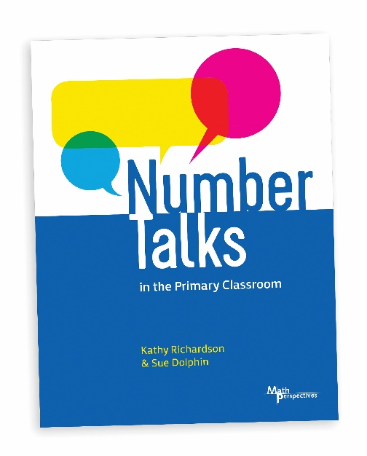
NUMBER TALKS
IN THE PRIMARY CLASSROOM
By Kathy Richardson and Sue Dolphin
During this one-day introduction course, teachers learn to help students acquire competence in computation using visual models and number relationships to build number sense and to develop numerically powerful strategies that make sense to students. Students work with numbers using strategies that are simple, yet meaningful and powerful. Teachers see these methods modeled as they observe children solving problems during Number Talks. Course time is also devoted to helping teachers strengthen their own understanding of mathematics.

IF YOU DO NOT OWN A COPY OF THE REQUIRED TEXT (above); PLEASE PURCHASE IT THROUGH OUR DISTRIBUTOR, DIDAX. LOCATED IN ROWLEY, MA; IN TIME TO HAVE IT FOR THE COURSE.
YOU CAN PURCHASE THE BOOK AT WWW.DIDAX.COM

