Assessing Math Concepts
June 17-20, 2024—Online Course

You will not need to purchase a new copy if you already have the book.

Assessing Math Concepts course $375.00
Assessing Math Concepts course with AMC book $440.00
Course materials and AMC book ship for free, please read last page of form.

It is also highly recommended that Kindergarten teachers have Developing Number Concepts Books 1 and 2; 1st grade teachers have Developing Number Concepts Books 1, 2 and 3; and 2nd grade teachers have Developing Number Concepts Books 2 and 3.

Course fee includes the provided course materials:
Math Perspectives Professional Development Refence & Reading Materials for Teachers of K-5 Mathematics
AMC Assessment Cards
PARTICIPANT REGISTRATION FORM

How to register: Please use one registration form for each participant; Registration fee or Purchase order must accompany your registration form. Mail, fax or email your completed form with payment to:
Mail: Math Perspectives, P.O. Box 29418, Bellingham, WA 98228
Email: with Subject line “Online Assessing Math Concepts Course” to erin@mathperspectives.com
You will be sent a confirmation email or letter when your completed registration is received. Sessions are filled on first-come, first-served basis. Limited space is available.

Participant Information:
Name | District/School | Title/Grade Level
Home Mailing Address | City, State/Province, Zip/Postal code
Work phone | Home phone | Cell phone
School email | Home email
Please check preferred email for Course correspondence.
Would you like to receive our Q&A eNewsletter by Kathy Richardson and other course emails? Yes No
PaYMENT Information:
Check or Money Order: Make payable to Math Perspectives.
Credit Card: Fill out authorization form included or call 360-715-2782.
Purchase Order: Complete all PO information below and provide a copy of the PO with your completed application.
PO Number |  | Total Registrants on PO
Institution | Billing Contact/Title
Billing Address | City/State/Zip
Billing Phone | Billing Fax
Cancellation Policy If you must cancel, a substitute participant is always welcomed. A full refund will be made if written cancellation is received at least 10 days before the first day of the session. If written cancellation is received less than 10 days prior to the session, a processing fee of $50.00 per participant will be charged. Participants who have not provided written cancellation according to this policy and do not attend the course forfeit their entire registration.

CREDIT CARD AUTHORIZATON FORM

Instructions: Please complete all credit card billing information; print legibly using dark ink.
Submit via mail or fax to:
Math Perspectives, P.O. Box 29418, Bellingham, WA 98228

I, ____________________________________________, hereby authorize Math Perspectives to charge my credit card account in the amount of $________________ (including shipping and handling, and/or taxes, if applicable).

Type of card:  VISA  Mastercard
Credit Card number | Expiration date |  | CVC code
Name as it appears on card
Card Billing Address |  | City, State/Province, Zip/Postal code
Contact Phone | Contact Email
By signing this form, I hereby authorize Math Perspectives to charge the credit card listed above for payment of fees, costs, and expenses. I certify that I am a person who is authorized to use this credit card. I agree to abide by the terms and conditions set forth as a credit card holder.
I have read and understand Math Perspectives cancellation policy.
Signature
Printed Name
Date
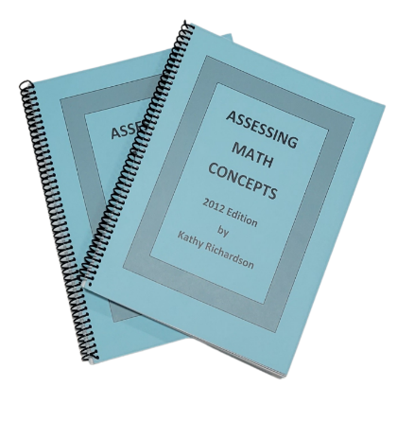
ASSESSING MATH CONCEPTS
By Kathy Richardson
Book Order Form
Assessing Math Concepts
by Kathy Richardson
$65.00, free shipping within Continental U.S.
Name |  | Email
Shipping Address |  | City/State/Zip
Cell Phone | School Phone | Home Phone | # of Copies
□ Credit Card payment | □ Check or money order (enclosed) | □ Purchase order no.__________ (attached) | _______
Card number |  | Expiration date | CVC code
CC Billing Address (if different from shipping) |  | City/State/Zip
Signature  Return completed Advance Order Form with payment to: |  | Date  Math Perspectives  P.O. Box 29418, Bellingham, WA 98228  Ph 360-715-2782 | Fax 360-715-2783  erin@mathperspectives.com
Assessing Math Concepts is a nine-part series of assessments that focus on core concepts that must be in place if children are to understand and be successful in mathematics.
The information that is gathered and organized helps the teacher's awareness of the important steps in the learning process and provides information for instructional decision making.
This book provides the teacher background information for giving and using all nine assessments, instructions for doing classroom observations, tips for organizing information and suggestions for instruction.

